**1. Be awesome! Be a book nut!**

“The more that you read, the more things you will know. The more that you learn, the more places you’ll go.” ~ Dr. Seuss

**2. Why fit in when you were born to stand out?**

**3. All creatures should be free.**

“And turtles, of course… all the turtles are FREE. As turtles and, maybe, ALL creatures should be.” ~ Dr. Seuss

**4. You know you’re in love when reality is finally better than your dreams.**

“You know you’re in love when you can’t fall asleep because reality is finally better than your dreams.” ~ Dr. Seuss

**5. Don’t cry because it’s over. Smile because it happened.**

“Remember me and smile, for it’s better to forget than to remember me and cry.” ~ Dr. Seuss

**6. Life’s too short too wake up with regrets.**

“Life’s too short to wake up with regrets. So love the people who treat you right, forgive the ones who don’t and believe that everything happens for a reason. If you get a chance, take it. If it changes your life, let it. Nobody said it’d be easy, they just promised it would be worth it.” ~ Dr. Seuss

[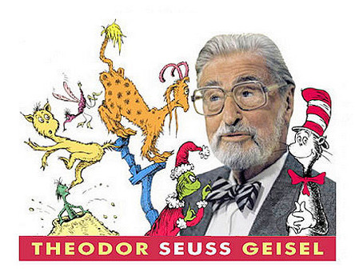](http://thespiritscience.net/wp-content/uploads/2015/11/143819190868196500.jpg)

**7. When you play, play hard; when you work, really work.**

“When he worked, he really worked. But when he played, he really PLAYED.” ~ Dr. Seuss

**8. Life is tough but you are tougher.**

“I have heard there are troubles of more than one kind. Some come from ahead and some come from behind. But I’ve bought a big bat. I’m all ready you see. Now my troubles are going to have troubles with me!” ~ Dr. Seuss

**9. There’s no limit to how far you can go.**

“So be sure when you step, step with care and great tact. And remember that life’s a Great Balancing Act. And will you succeed? Yes! You will, indeed! (98 and ¾ percent guaranteed) Kid, you’ll move mountains.”~ Dr. Seuss

**10. Be yourself, unapologetically!**

“Be who you are and say what you feel, because those who mind don’t matter and those who matter don’t mind.” ~ Dr. Seuss

**11. To the world you may be one person; but to one person you may be the world.**

“To the world you may be one person; but to one person you may be the world.” ~ Dr. Seuss

**12. We are all a little weird…**

[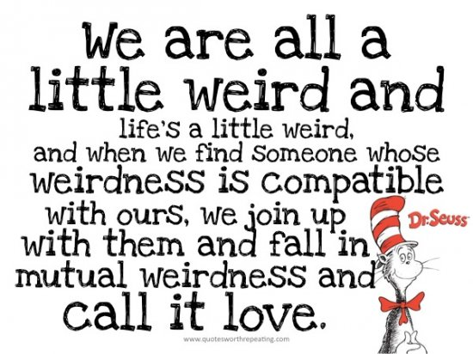](http://thespiritscience.net/wp-content/uploads/2015/11/dr-seuss-love-quote.jpg)

**13. Nonsense wakes up the brain cells.**

“I like nonsense, it wakes up the brain cells. Fantasy is a necessary ingredient in living, it’s a way of looking at life through the wrong end of a telescope. Which is what I do, and that enables you to laugh at life’s realities.” ~ Dr. Seuss

**14. Life’s  a a great balancing act**

“So be sure when you step. Step with care and great tact and remember that life’s a Great Balancing Act.”

**15. You are you. Now, isn’t that pleasant?**

[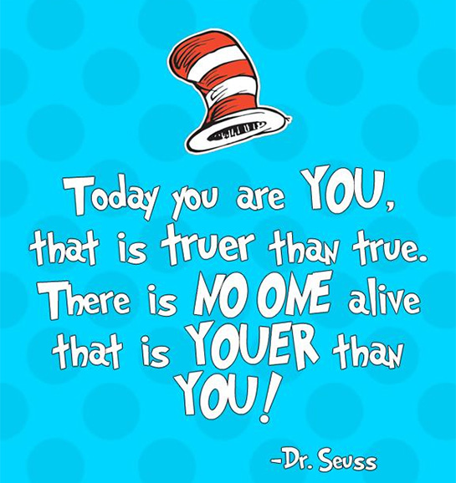](http://thespiritscience.net/wp-content/uploads/2015/11/Today-You-Are-You.jpg)

**16. Think and wonder, wonder and think.**

“Think left and think right and think low and think high. Oh, the thinks you can think up if only you try!” ~ Dr. Seuss

**17. If things start happening, don’t worry, don’t stew, just go right along.**

“If things start happening, don’t worry, don’t stew, just go right along and you’ll start happening too.” ~ Dr. Seuss

**18. Don’t cry because it’s over, smile because it happened.**

**19. A person’s a person, no matter how small.**

“A person’s a person, no matter how small.” ~ Dr. Seuss

**20. A person’s a person, no matter how small.**

“A person’s a person, no matter how small.” ~ Dr. Seuss

**21. It’s not about what it is, it’s about what it can become.**

“It’s not about what it is, it’s about what it can become.” ? Dr. Seuss